Create a file
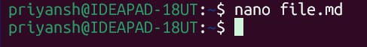
file.md - script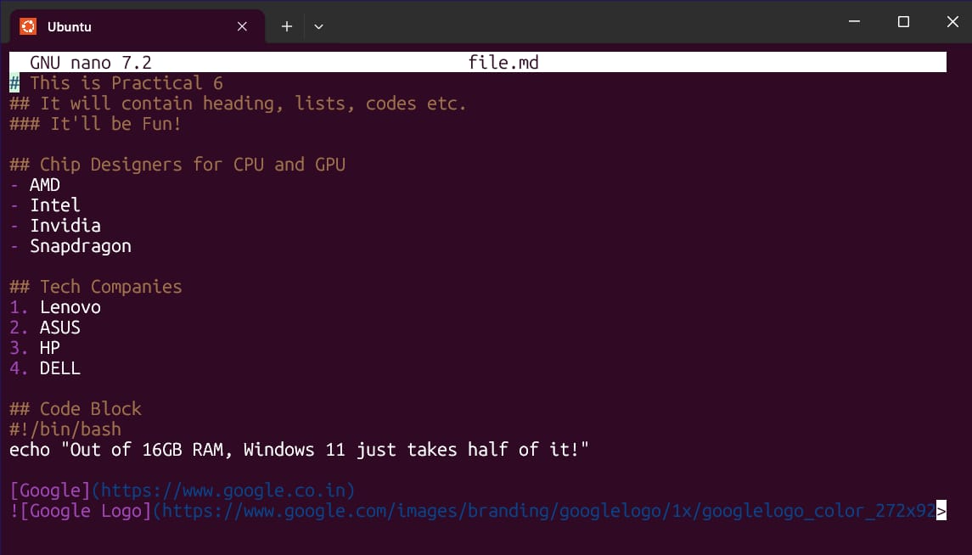
Install Pandoc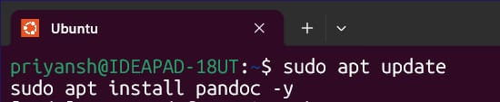
Convert the file to HTML then open it
NOTE: If you face any errors-
- Install XDG Utilities
- Install a Brower (e.g. Firefox) 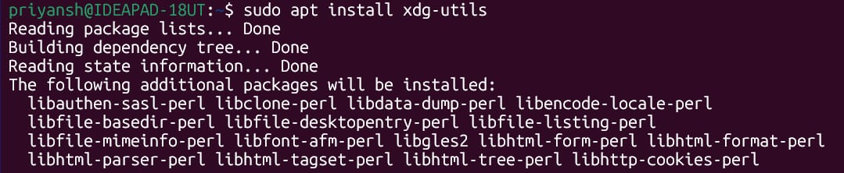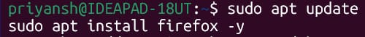
Use the browser (here Firefox) to run the file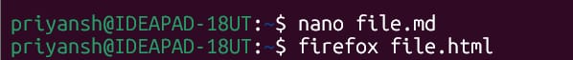
NOTE: Any changed made to .md file won’t reflect directly so make sure to convert it after any changes made to it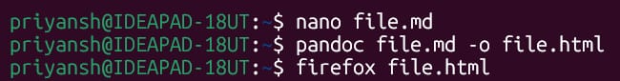
In Browser – file.html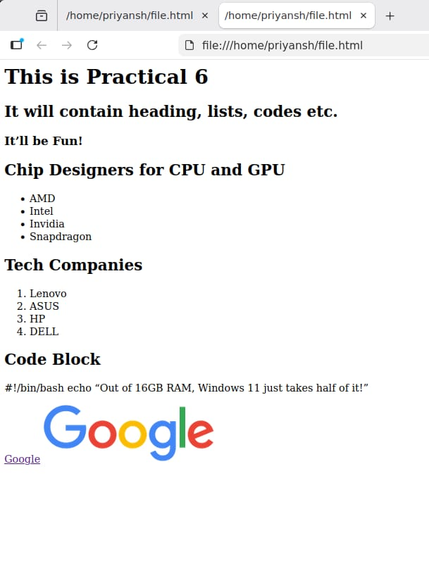
Convert file to PDF
To View Code in VS Code –
write above the script and then use Ctrl+ Shift + V (to open VS Code)
Note: VS Code may ask for permission if you have it installed recently.
VS Code Editor View 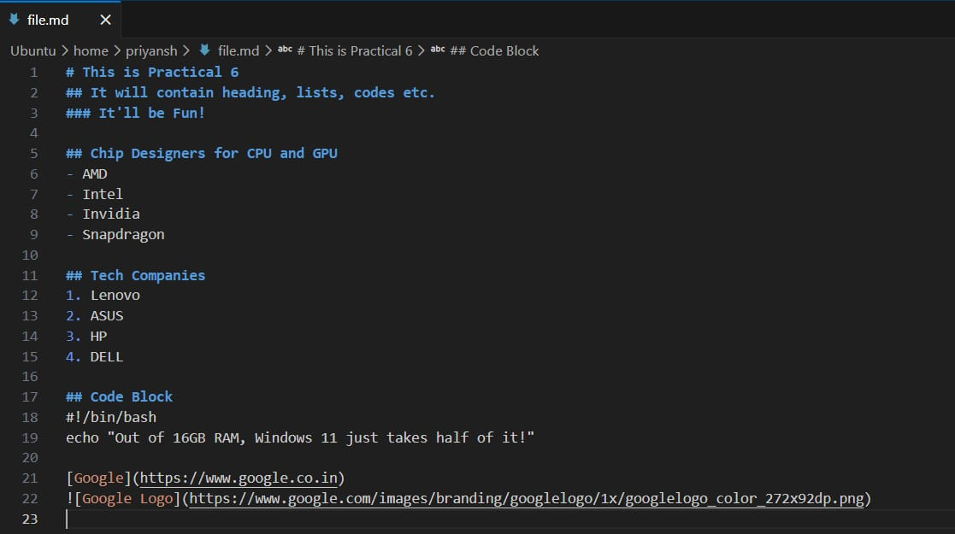

NOTE: You can get your Files in -
Linux < Ubuntu < Home < Use

